**CHAPTER 3**

**RESEARCH METHODOLOGY**

The goal of this chapter is to talk about how to do research. The methodology is concerned with the project's process and flow. To conduct the research utilising the waterfall approach, this project follows the Software Development Lifecycle (SDLC). Identification, design, development, prototyping, testing, deployment, and maintenance are the five phases of the waterfall model.

**3.1 Software Development Methodology**

The waterfall model was employed as the project's fundamental basis. This paradigm is appropriate for the creation of mobile applications. Each waterfall phase is defined and described in detail. Figure 3.1 depicts the waterfall model.

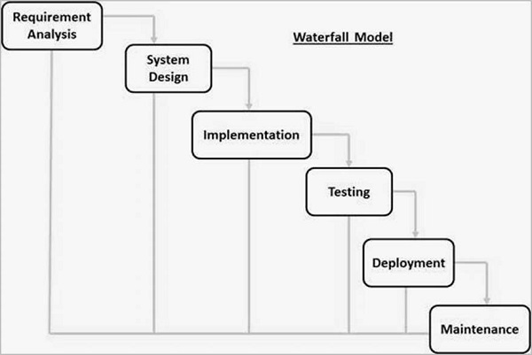

**Figure 3.1** Waterfall Model

The waterfall model contains six phases, as shown in Figure 3.1. The first is the system's requirements analysis where a list of possible needs will be gathered and then will be documented in a specific document. Second phases of waterfall model are system design which will cover the design of the application architecture. The component and functional testing will be implemented in the implementation phase. The testing phase is for integrating the generated unit into the system, where the system will test for failures or defects. When the application is ready to be deployed. The final step is the maintenance phase, during which the system is improved.

**3.2 Project Framework**

The project framework for this project is described in this section (see Table 3.1). The project framework's phases will correspond to the phases of the software development process. The project framework's phases are matched to the objectives.

**Table 3.1** Project Framework

|  |  |  |  |
| --- | --- | --- | --- |
| Objective | Phase | Activity | Outcome |
| Objective 1:  To identify features that can be included in the proposed web base application regarding chat management system. | Requirement Analysis | * Define project title * Define problem statement * Doing research through internet journal and publications to support problem statement * Define objective, scope, and requirements * Literature review research | * Problem statement * Objective * Scope and significant * Comparison of existed application |
| Objective 2:  To design and develop chat management system to assist the administrator in managing the student chat activities. | System Design | * Design system flowchart * Design system Entity Relation Diagram (ERD) * Design use case diagram * Design Graphical User Interface (GUI) | * System flowchart * System Entity Relation Diagram * Use Case Diagram * User Interface Design |
|  | Implementation | * Develop the system using Visual Studio, MongoDB, Brave browser, and Command Prompt. | * Virtual Buddy Application: Chat Management System |
| Objective 3:  To evaluate functionality of the developed system. | System Testing | * Test Case generation | * Test Result |
|  | System Deployment | * Deployment of the system | * The end user can use the system |
|  | System Maintenance | * Fix faults or bug | * The system will have a new update and improvement |

The objective 1 can be achieved by implementing the requirements analysis phase. The problem statement, objective, comparison of existing applications, scope and significance are the outcomes for objective 1. The system design and implementation process can be used to achieve objective 2. The system flowchart, system Entity Relation Diagram (ERD), Use Case Diagram, user interface design, and the Virtual Buddy Application: Chat Management system are the outcomes for objective 2. Implementing the system testing, deployment, and maintenance phases will help you reach objective 3. The test results will be delivered, the end user will be able to utilise the system, and the system will be updated and improved.

**3.3 Phase 1 Requirement Analysis**

The requirement analysis phase is the first and most important step of the software development lifecycle, where it gathers data to design a proper system. Some material connected to the project has been found through internet journals and publications to identify the needs needed in this project. The goal of this project is to develop a chat management system that will control the user chat activity. This project uses Progressive Web Application approach that has many advantages in a system development. The analysis is carried out by contrasting existing system related to chat management.

**3.4 Phase 2 System Design**

The design phase is the second phase of the waterfall model, and it describes how the system is designed. 3.3.1 displays the system's architecture. Next, 3.3.2 will show the use case diagram. It is followed by the user interface design in 3.3.3, which depicts the system overview.

**3.4.1 Flowchart**

A flowchart is used to better comprehend the system's processes. The system flowchart is shown in Figure 3.2.

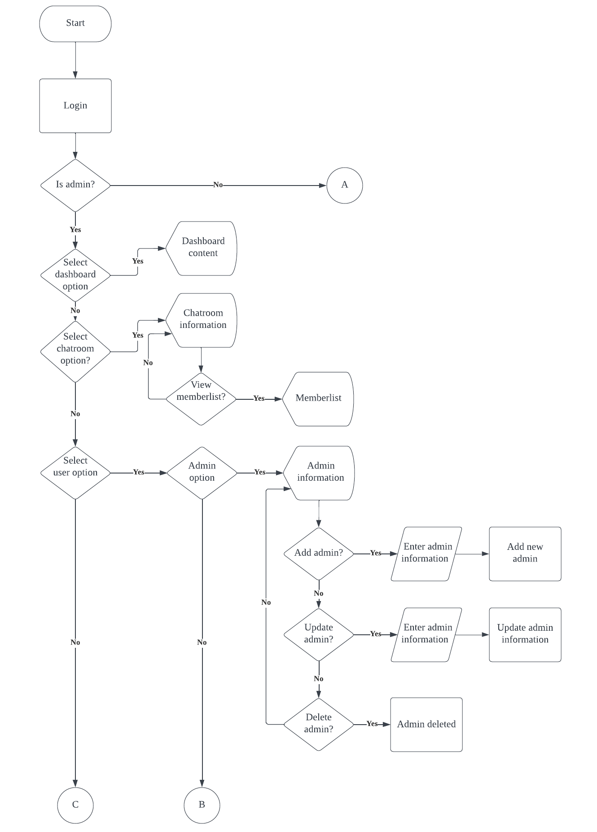

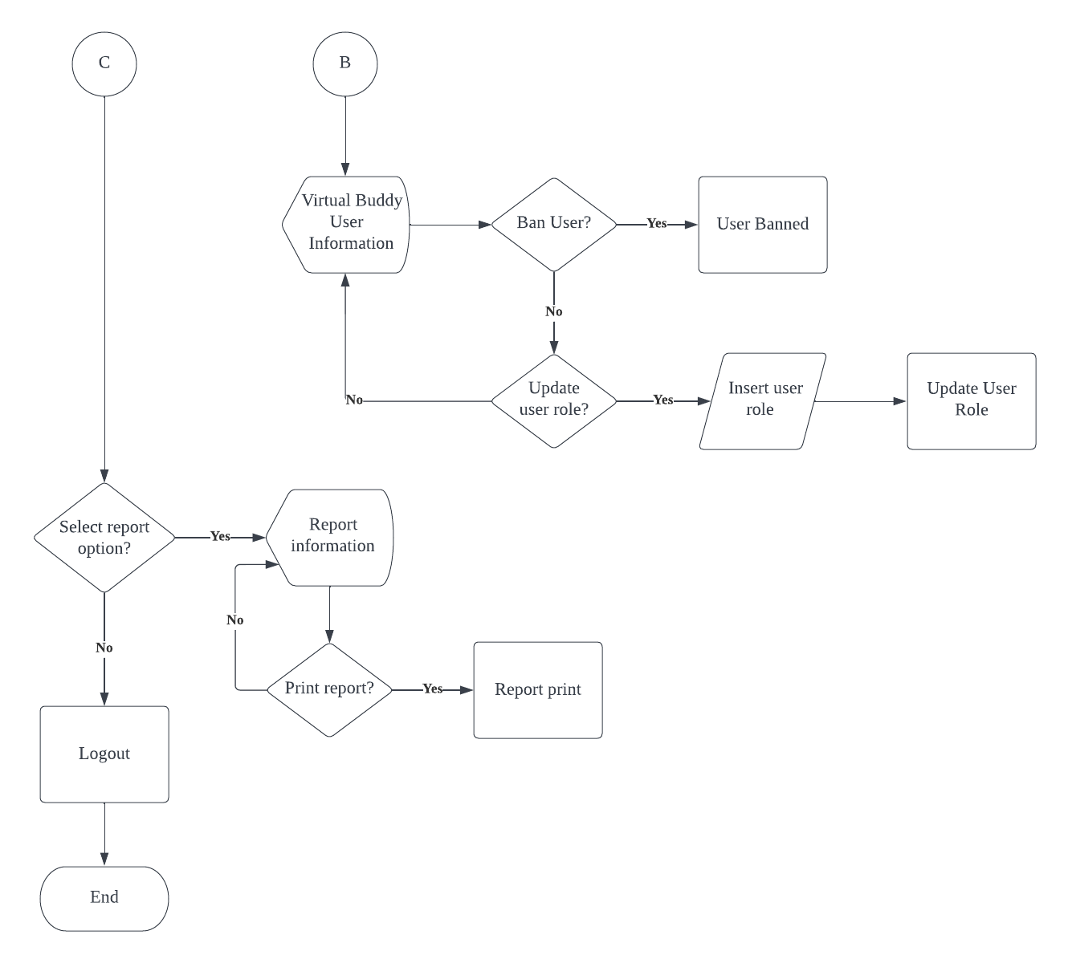

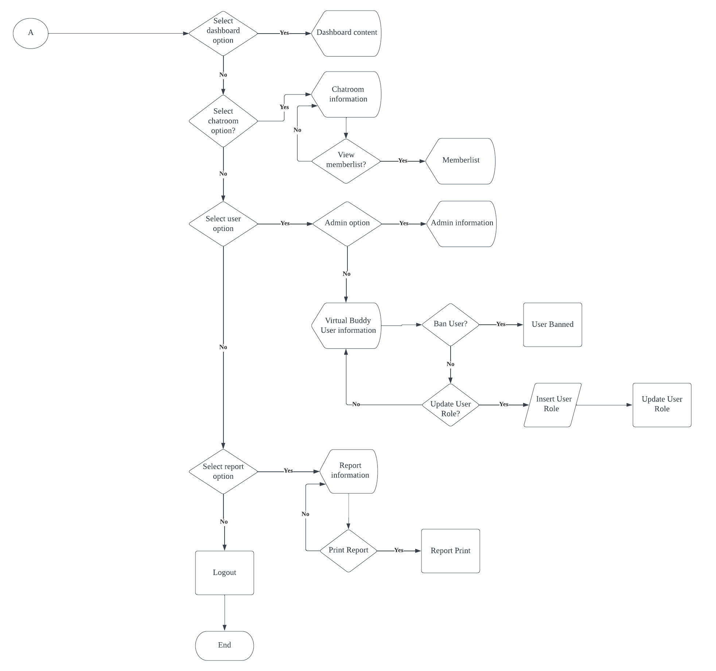

**Figure 3.2** System Flowchart

First, the user needs to login into the system. Then the system will check either the user is super admin or admin. If the user is super admin, he or she will be redirect to super admin page. The admin can do exactly same as super admin except the admin cannot do the add, update, and delete process in the admin list page. Next, at the navigation bar in super admin page, the user needs to select from four option either to select dashboard, chatroom, user, or report option. If the user selects the dashboard option, the system will display some of the information from the database such as the number of admin and the number of Virtual Buddy user. Next, if the chatroom option being selected by the user, the system will display the chatroom information. In this page, there will be one option that can be made by the user which is to view the member list of the chatroom. If the user chooses to view the member list, the system then will display the member list information. The next option that can be made from the navigation bar is the user option. There will be two more option that user must select either admin list option or Virtual Buddy User option. In the admin list option, the user will be able to view the admin information and will be able to do three operation which is add admin, update admin, and delete admin. If the user chooses not to select the admin list option, the system then will display the Virtual Buddy user page. The user will be able to view the Virtual Buddy user information and can do two operation that is update user role and ban user. The last option that user can make from the navigation bar is report option. The system will display the report information to the user and the user can choose to print the report or not. If there are no option that be made by the user, the user can choose to logout from the system.

**3.4.2 Pseudocode**

Pseudocode is short for "fake code." It is a haphazard and contrived method of developing programmes in which developer portray the sequence of actions and instructions also known as algorithms in a style that humans can understand. Table 3.2 shows the pseudocode for this system.

|  |  |
| --- | --- |
| Add admin | START  Click Add button  DISPLAY add form  INPUT name, email, role, address, phoneNumber  Click Save button  IF Save button = true  THEN add user input to admin table in the database  PRINT add admin success  ELSE  Redirect to admin page  END |
| Update Admin | START  Click Edit button  DISPLAY edit form  INPUT name, email, role, address, phoneNumber  Click Update button  IF Update button = true  THEN update admin table in database  PRINT update admin success  ELSE  Redirect to admin page  END |
| Ban User | START  Click Ban button  DISPLAY conformation alert  Click Yes button  IF Yes button = true  THEN Update user status to Ban from user table in the database  ELSE Redirect to user page  END |
| Unban User | START  Click Unban button  DISPLAY conformation alert  Click Yes button  IF Yes button = true  THEN Update user status to Active from user table in the database  ELSE Redirect to user page  END |

**Table 3.2** Use Case Diagram of Virtual Buddy App: Chat Management

**3.4.3 Use Case Diagram**

The use case diagram for the proposed web-based system is shown in Figure 3.4. There is two actor that is super admin and admin. Next, there is twelve use cases which is view admin, add admin, update admin, delete admin, view chatroom information, view member, view Virtual Buddy User list, ban user, unban user, update role, view role and print report.

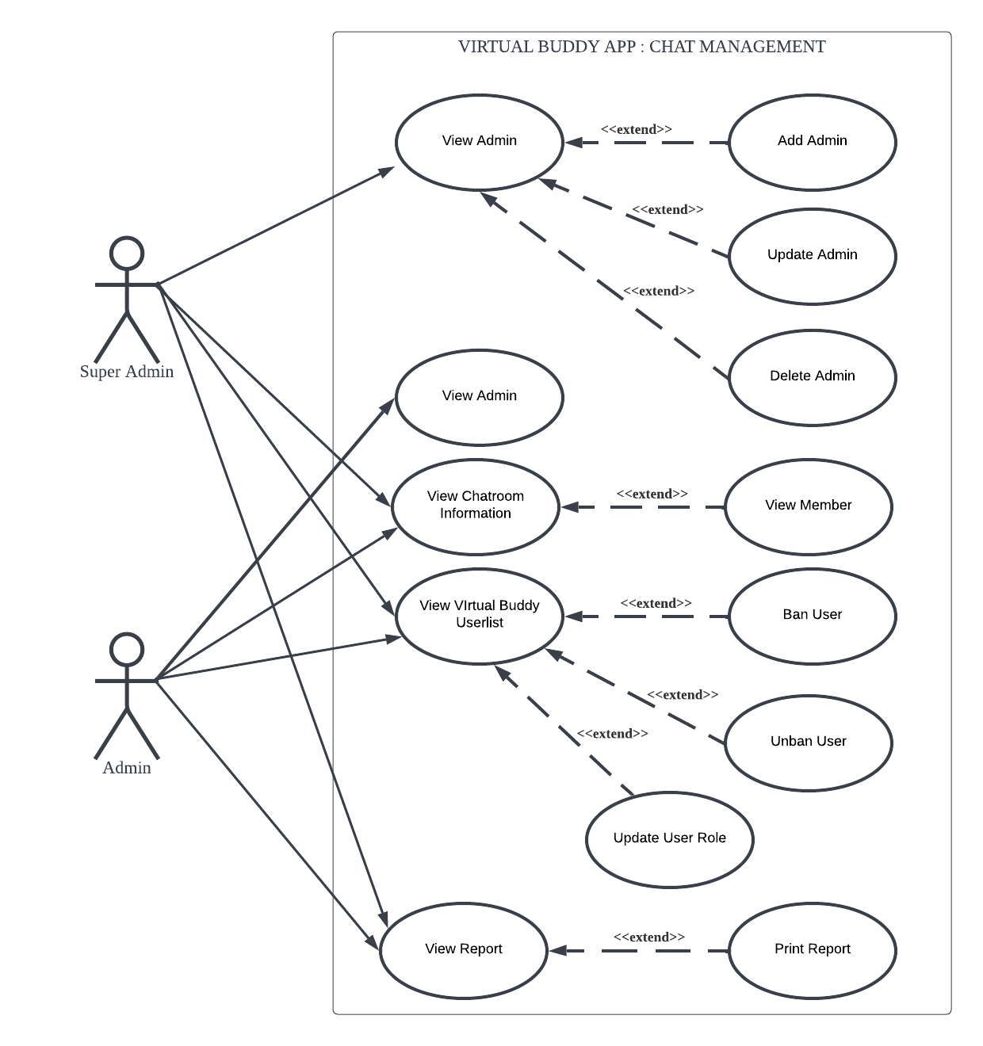

**Figure 3.4** Use Case Diagram of Virtual Buddy App: Chat Management

**Table 3.3** Use Case Description of View Admin

|  |  |
| --- | --- |
| Use Case ID | UC 001 |
| Use Case | View Admin |
| Purpose | To view admin information |
| Actors | Super Admin, Admin |
| Precondition | 1. The user is successfully logged in.  2. The user has selected the “Admin” button on navigation bar. |
| Main Flow | The user can view the admin list. |

**Table 3.4** Use Case Description of Add Admin

|  |  |
| --- | --- |
| Use Case ID | UC 002 |
| Use Case | Add Admin |
| Purpose | To add new admin |
| Actor | Super Admin |
| Precondition | 1. The user is correctly logged in as a super admin.  2. The user has selected the “Admin” button on navigation bar.  3. The user has selected the “Add” button. |
| Main Flow | 1. Super admin fill in all the information needed.  2. Super admin click the “Submit” button to submit the information. |
| Alternative Flows | 1. Success message is returned; the admin is successfully added.  2. Super admin select “Cancel” button; the system returns to admin list page. |

**Table 3.5** Use Case Description of Update Admin

|  |  |
| --- | --- |
| Use Case ID | UC 003 |
| Use Case | Update Admin |
| Purpose | To update admin information |
| Actor | Super Admin |
| Precondition | 1. The user is correctly logged in as a super admin.  2. The user has selected the “Admin” button on navigation bar.  3. The user has selected the “Update” button. |
| Main Flow | 1. Super admin fill in all the information needed.  2. Super admin click the “Update” button to update the information. |
| Alternative Flows | 1. Success message is returned; the admin information is successfully updated.  2. Super admin select “Cancel” button; the system returns to admin list page. |

**Table 3.6** Use Case Description of Delete Admin

|  |  |
| --- | --- |
| Use Case ID | UC 004 |
| Use Case | Delete Admin |
| Purpose | To delete the admin |
| Actor | Super Admin |
| Precondition | 1. The user is correctly logged in as a super admin.  2. The user has selected the “Admin” button on navigation bar. |
| Main Flow | 1. Super admin click the “Delete” button to delete the information.  2. Super admin click the “Yes” button to confirm to delete the information |
| Alternative Flows | 1. Success message is returned; the admin information is success to delete.  2. Super admin select “Cancel” button; the system returns to admin list page. |

**Table 3.7** Use Case Description of View Chatroom Information

|  |  |
| --- | --- |
| Use Case ID | UC 005 |
| Use Case | View Chatroom Information |
| Purpose | To view the chatroom information |
| Actors | Super Admin, Admin |
| Precondition | 1. The user is successfully logged in  2. The user has selected the “Chatroom” button on navigation bar |
| Main Flow | User can view the chatroom information |

**Table 3.8** Use Case Description of View Member

|  |  |
| --- | --- |
| Use Case ID | UC 006 |
| Use Case | View Member |
| Purpose | To view the member in the chatroom |
| Actors | Super Admin, Admin |
| Precondition | 1. The user is successfully logged in  2. The user has selected the “Chatroom” button on navigation bar  3. Users click the “View Member” button to view the member |
| Main Flow | User can view the chatroom information |

**Table 3.9** Use Case Description of View Virtual Buddy User List

|  |  |
| --- | --- |
| Use Case ID | UC 007 |
| Use Case | View Buddy User List |
| Purpose | To view the Virtual Buddy user |
| Actors | Super Admin, Admin |
| Precondition | 1. The user is successfully logged in  2. The users has selected the “VB User List” button on navigation bar |
| Main Flow | User can view the virtual buddy information |

**Table 3.10** Use Case Description of Ban User

|  |  |
| --- | --- |
| Use Case ID | UC 008 |
| Use Case | Ban User |
| Purpose | To ban users who break the rules |
| Actors | Super Admin, Admin |
| Precondition | 1. The user is successfully logged in  2. The user has selected the “VB User List” button on navigation bar |
| Main Flow | 1. The user has selected the “Ban” button  2. The users click the “Yes” button to confirm to ban the Virtual Buddy User |
| Alternative Flows | 1. Success message is returned; the virtual buddy user is banned.  2. The users select “Cancel” button; the system returns to virtual buddy user list page. |

**Table 3.11** Use Case Description of Unban User

|  |  |
| --- | --- |
| Use Case ID | UC 009 |
| Use Case | Unban User |
| Purpose | To unban users who has been ban |
| Actors | Super Admin, Admin |
| Precondition | 1. The user is successfully logged in  2. The user has selected the “VB User List” button on navigation bar |
| Main Flow | 1. The user has selected the “Unban” button  2. The users click the “Yes” button to confirm to unban the Virtual Buddy User |
| Alternative Flows | 1. Success message is returned; the virtual buddy user is unbanned.  2. The users select “Cancel” button; the system returns to virtual buddy user list page. |

**Table 3.12** Use Case Description of Update Virtual Buddy User Role

|  |  |
| --- | --- |
| Use Case ID | UC 010 |
| Use Case | Update Virtual Buddy User Role |
| Purpose | To update virtual buddy user role |
| Actors | Super Admin, Admin |
| Precondition | 1. The user is successfully logged in  2. The user has selected the “VB User List” button on navigation bar |
| Main Flow | 1. The user has selected the “Unban” button  2. The users click the “Update” button to update the user role  3. Super admin or admin change the role of user either a student or Virtual Buddy. |
| Alternative Flows | 1. Success message is returned; the virtual buddy user role is updated  2. The users select “Cancel” button; the system returns to virtual buddy user list page |

**Table 3.13** Use Case Description of View Report

|  |  |
| --- | --- |
| Use Case ID | UC 011 |
| Use Case | View Report |
| Purpose | To view the reports |
| Actors | Super Admin, Admin |
| Precondition | 1. The user is successfully logged in  2. The user has selected the “Reports” button on navigation bar |
| Main Flow | The user can view the reports |

**Table 3.14** Use Case Description of Print Report

|  |  |
| --- | --- |
| Use Case ID | UC 012 |
| Use Case | Print Report |
| Purpose | To print the report |
| Actors | Super Admin, Admin |
| Precondition | 1. The user is successfully logged in  2. The user has selected the “Report” button on navigation bar |
| Main Flow | 1. The user has selected the “Print” button  2. The users click the “Print Page” button to print the page. |
| Alternative Flows | The users select “Cancel” button; the system returns to report page. |

**3.3.4 User Interface Design**

Figure 3.5 shows the login interface. In this page, the login form page will be shown that contains the user email input and password.

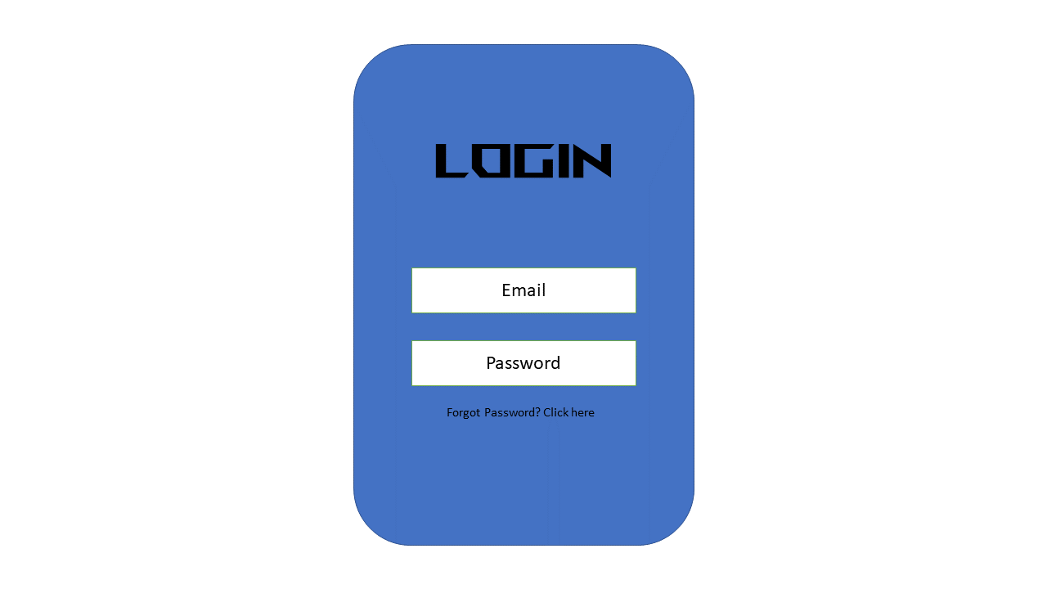

**Figure 3.5** Login Interface

Figure 3.6 shows the dashboard interface. In dashboard, some of the system data will be shown as the number of chat room, admin, Virtual Buddy user and the report.

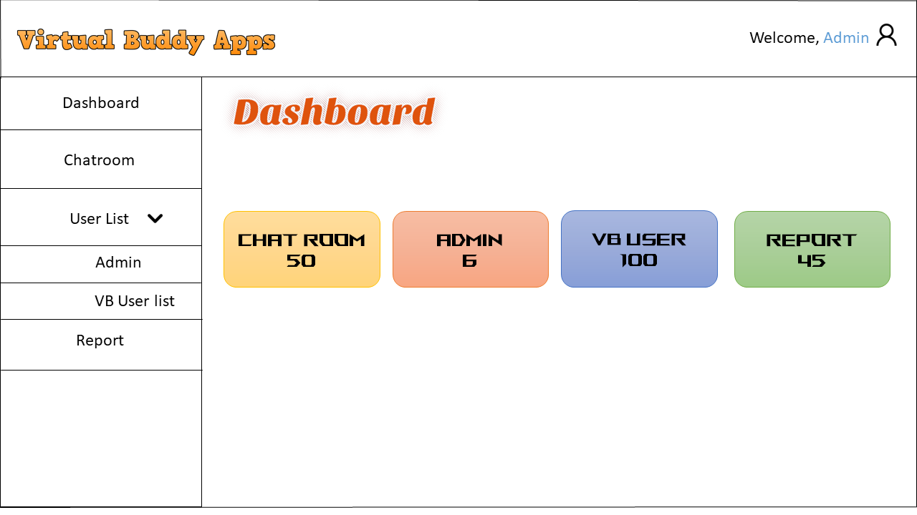

**Figure 3.6** Dashboard Interface

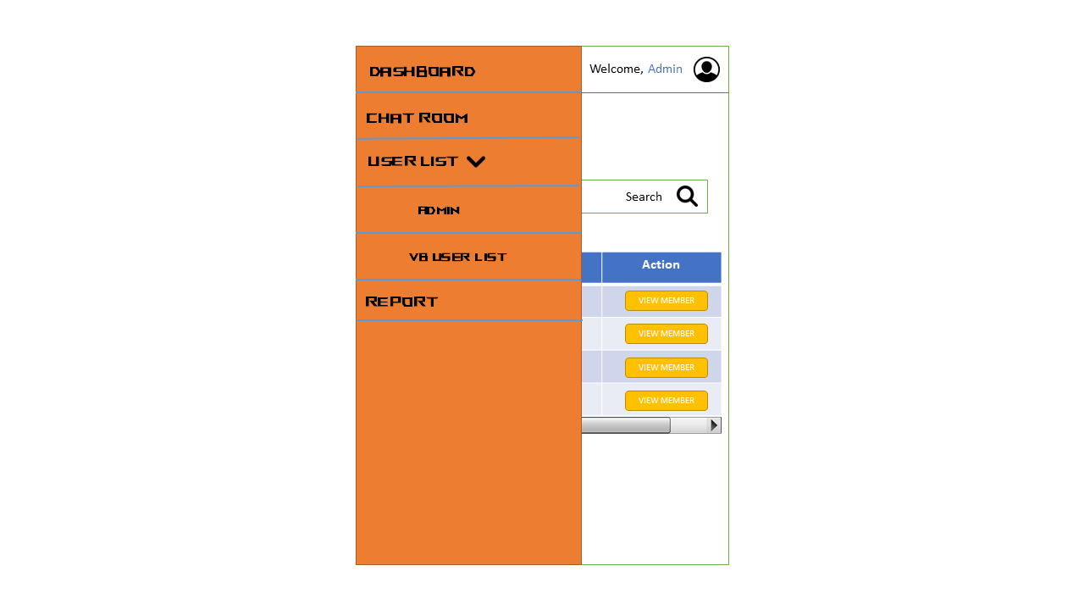

**Figure 3.7** Sidebar in Mobile View

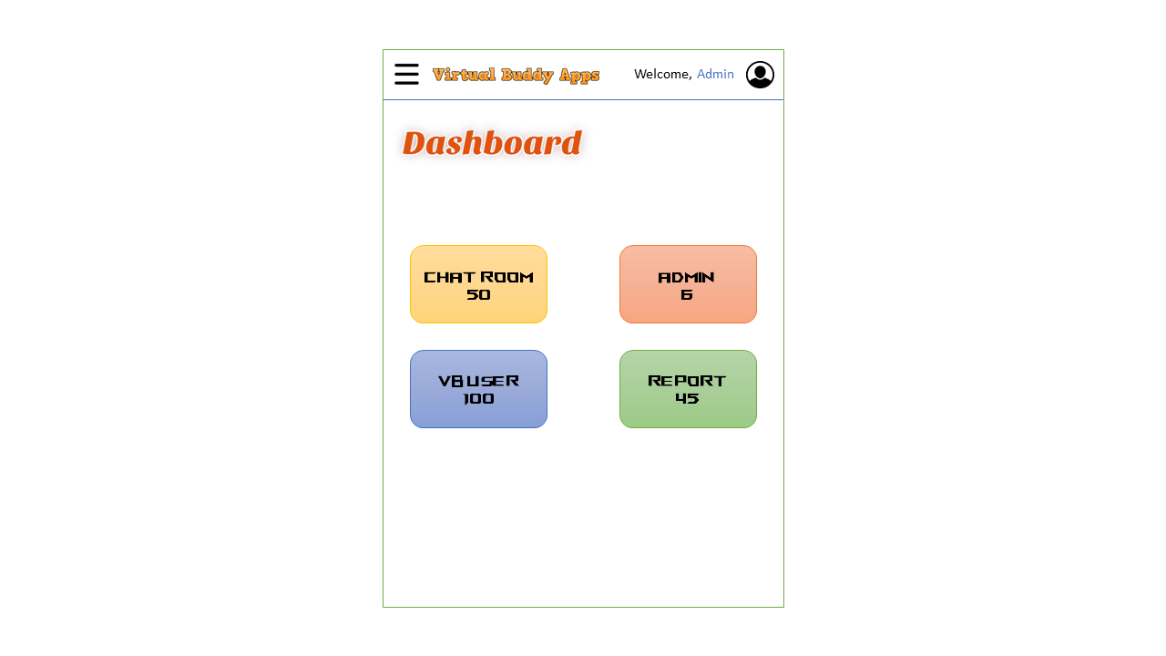

**Figure 3.8** Dashboard Interface in Mobile View

Figure 3.9 shows the chatroom interface where the information of the chatroom will be shown here. There is also a view member button to enable the user to view the member list of the chat room.

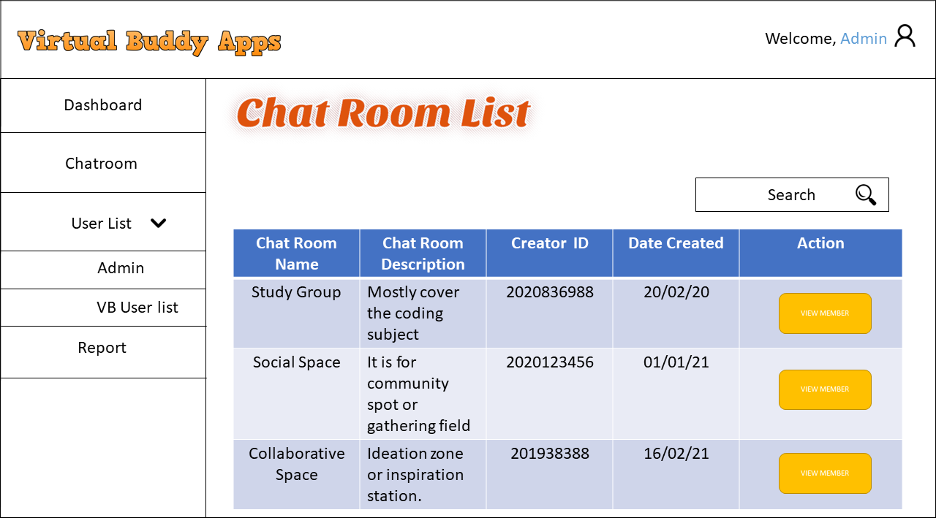

**Figure 3.9** Chatroom list interface

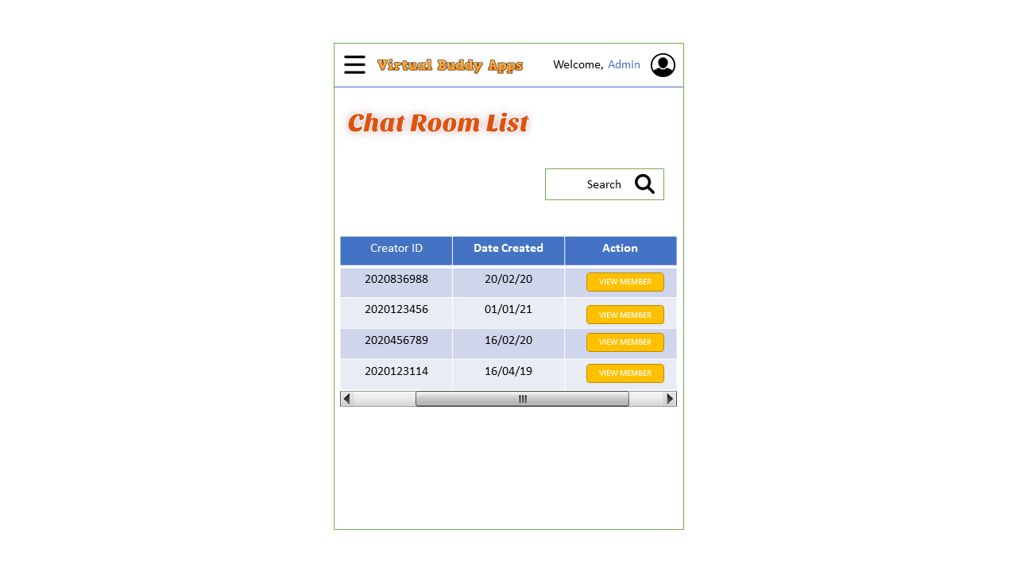

**Figure 3.10** Chatroom List Interface in Mobile View

Figure 3.11 shows the admin list interface. In this page the administrator information will be shown. There is three option that can be make here such as add new admin, update the admin information, and delete the admin.

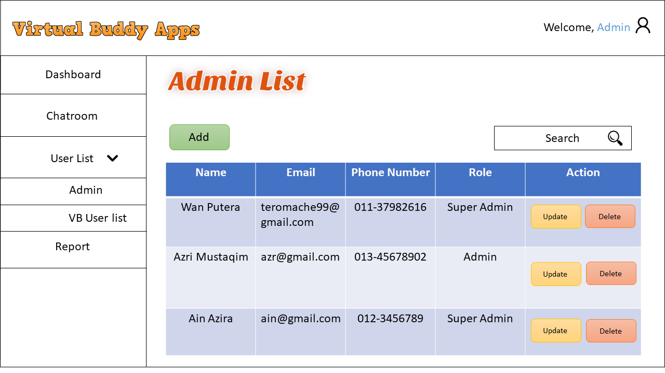

**Figure 3.11** Admin List Interface

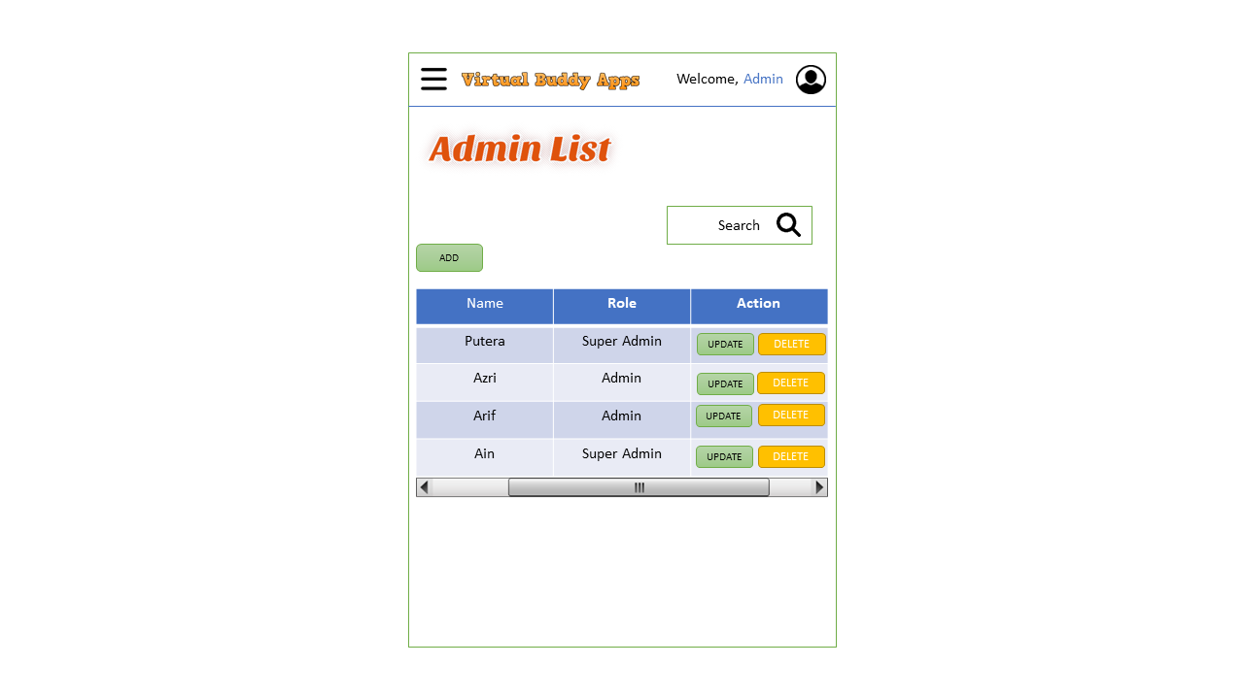

**Figure 3.12** Admin List Interface in Mobile View

Figure 3.13 shows the admin list add new user interface. In this page, the add form to add the new admin will be display.

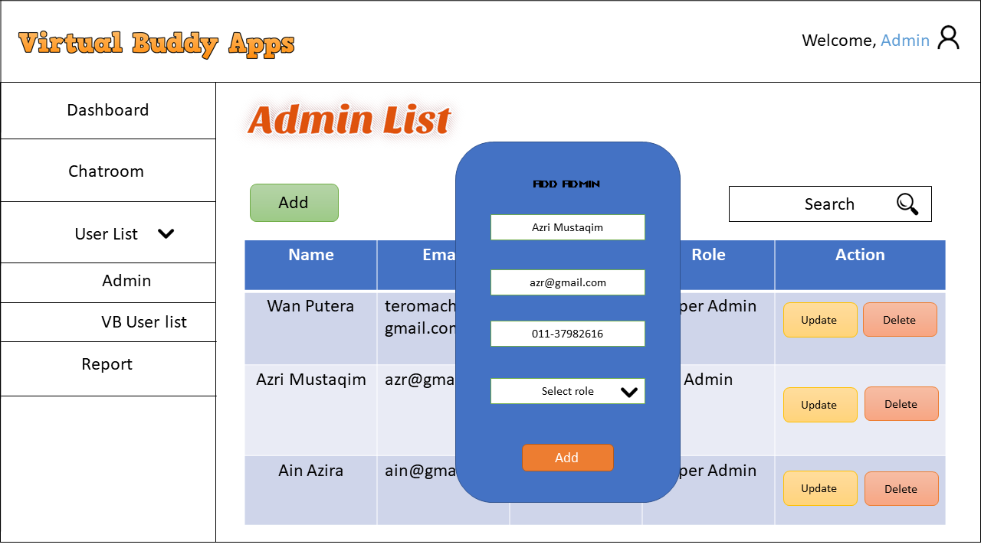

**Figure 3.13** Admin List Add New User Interface

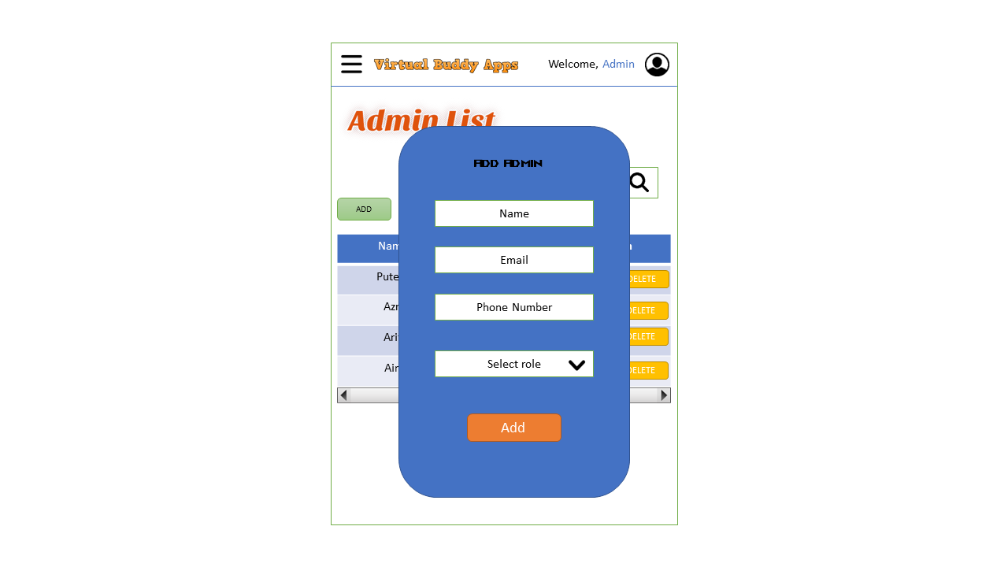

**Figure 3.14** Admin List Add New User Interface in Mobile View

Figure 3.15 shows the admin list update user interface. In this page, the update form to update the admin will be display.

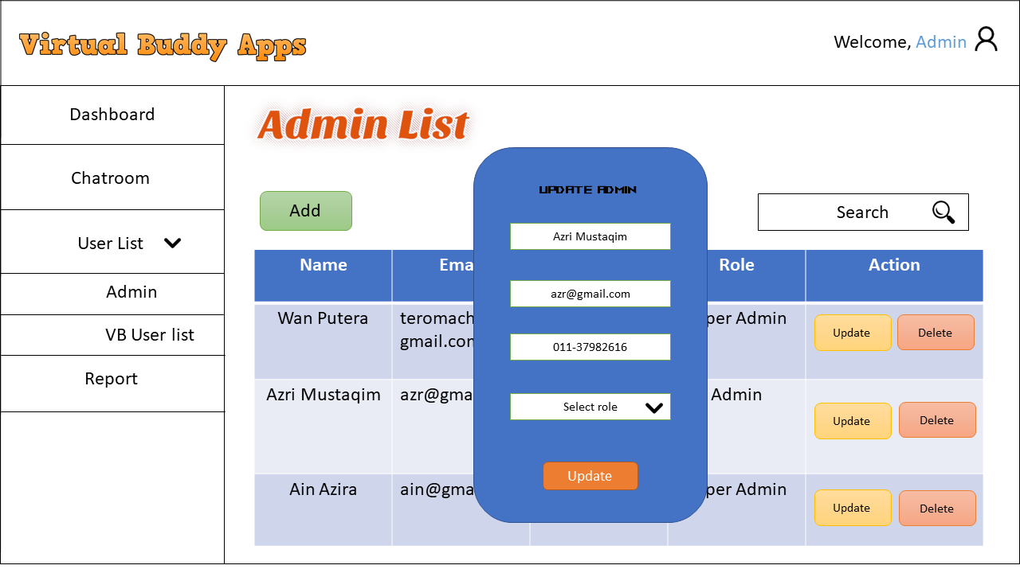

**Figure 3.15** Admin List Update User Interface

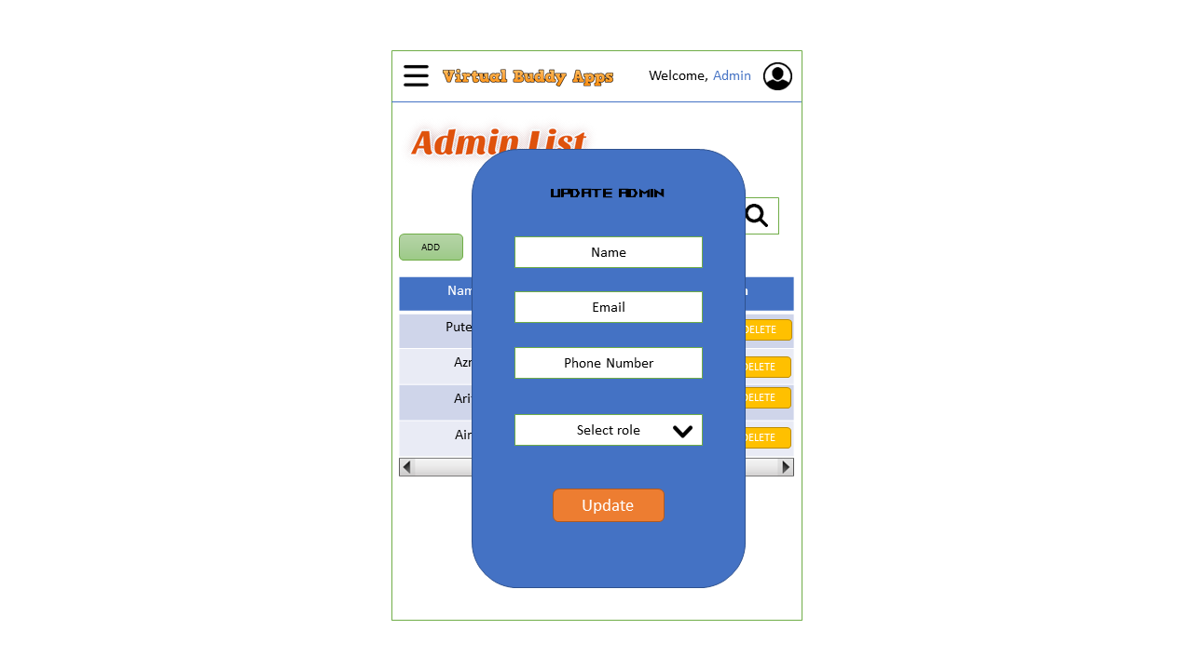

**Figure 3.16** Admin List Update User Interface

Figure 3.17 shows the virtual buddy user list interface. In this page, the information about virtual buddy user will be shown and there is also some action can be taken here such as ban user and update the user role.

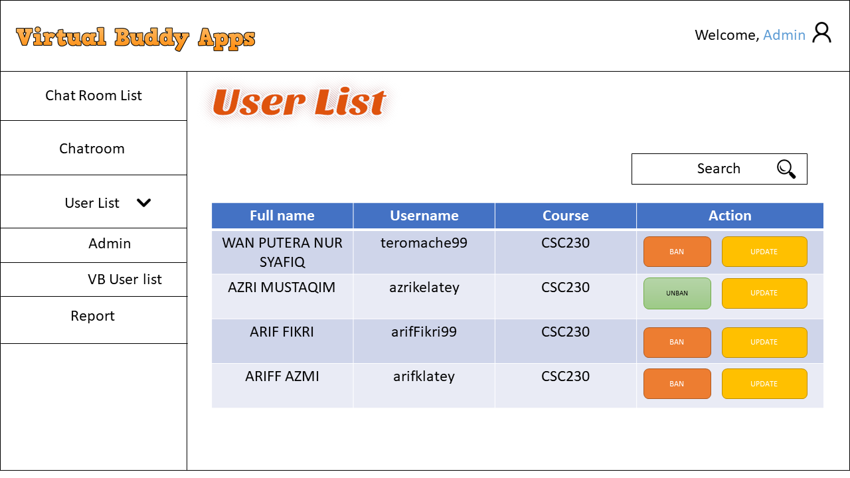

**Figure 3.17** Virtual Buddy User List Interface

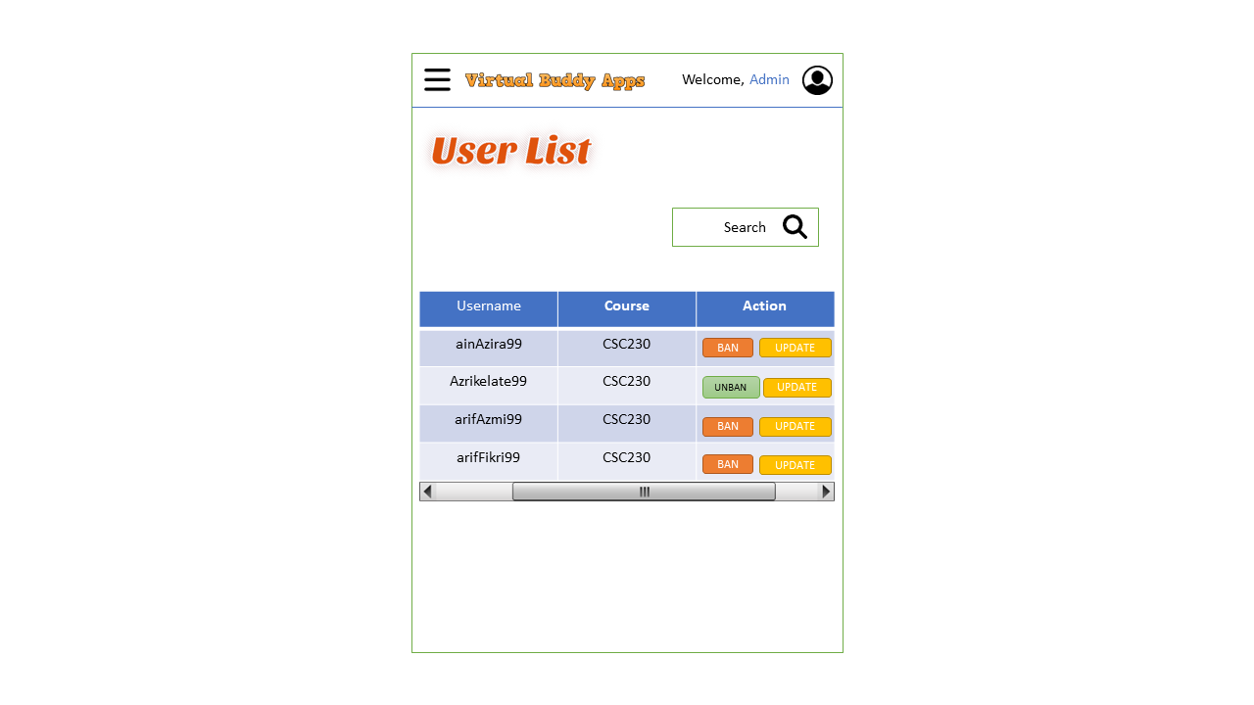

**Figure 3.18** Virtual Buddy User List Interface in Mobile View

Figure 3.19 shows the virtual buddy user role update interface. In this page, the form of user role update will be shown.

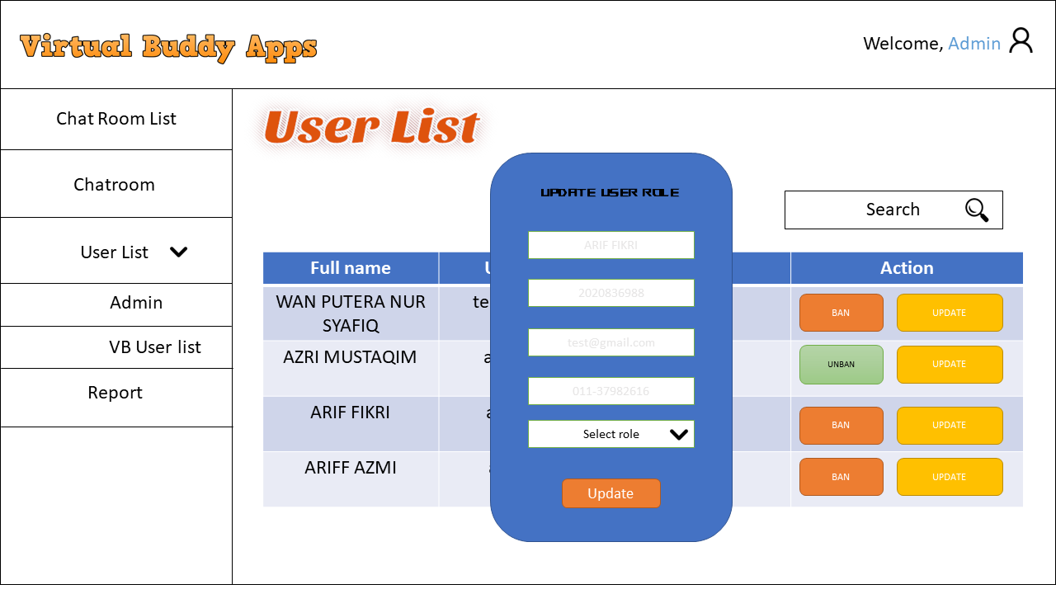

**Figure 3.19** Virtual Buddy User Role Update Interface

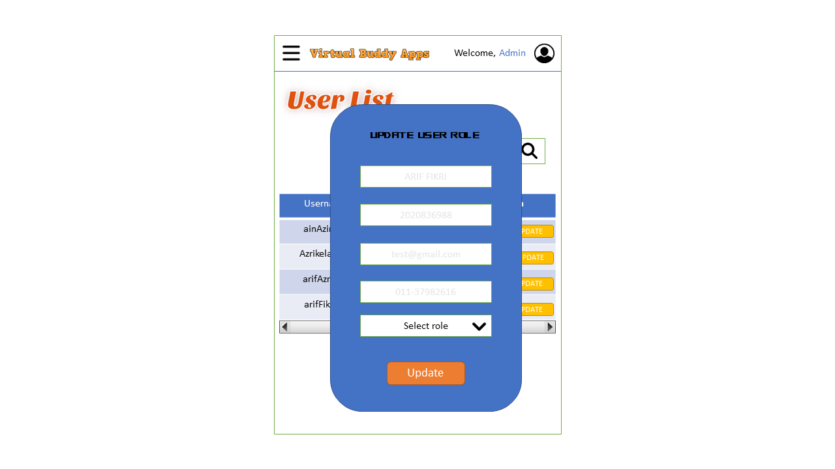

**Figure 3.20** Virtual Buddy User Role Update Interface in Mobile View

Figure 3.21 shows the report page interface. In this page, the information about report that has been made by user will be displayed. There is also print button that will print the report page.

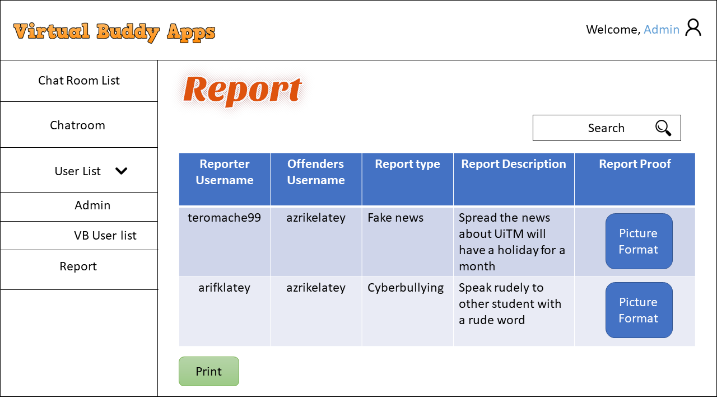

**Figure 3.21** Report Interface



**Figure 3.22** Report Interface in Mobile View

**3.4 Phase 3 Implementation**

The technique, related tools, and software that will be employed in the proposed system are described in this section. The system is a Progressive Web Application where both PC and mobile user can use it. The software that will be used to construct the proposed system is shown in Tables 3.14 and 3.15.

|  |  |
| --- | --- |
| **HARDWARE** | |
| **Specification** | **Description** |
| OS name | Microsoft Windows 11 |
| OS manufacture | Microsoft Corporation |
| System type | x64-based pc |
| Physical ram | 16gb |
| Device memory | 1tb SSD and 1tb HDD |
| Device processor | Intel Core i7 10th Gen |
| Device graphic processor | Nvidia RTX2060 |

**Table 3.15** Specification of Device Used.

The device specification that will be used to construct this project is shown in Table 3.14. Microsoft Windows 11 is the operating system on the device, while Microsoft Corporation is the manufacturer of the operating system. It has an 16GB random access memory (RAM) a 1tb SSD and 1tb HDD for read-only memory (ROM). Next, this device's processor is Intel Core i7 10th Gen. Finally, this device use Nvidia RTX 2060 for the graphic processor.

|  |
| --- |
| **Software** |
| Visual Studio |
| MongoDB |
| Brave browser |
| Command Prompt |

**Table 3.16** Software Requirement.

The software that will be used to develop the system is shown in Table 3.15. The first piece of software is Visual Studio, which is used to write the code for the system. The proposed system data will then be stored in a database created with MongoDB. Then there's Brave browser, where the preview of the system will be display here. Lastly, command prompt will be used to run some of Laravel code.

**3.5 Phase 4 Testing**

The prototyping phase is the next step. After the system has been completed, this phase will be completed. It is necessary to ensure that the system is free of errors. Each component of the system will be thoroughly examined to ensure that it functions properly.

**3.5.1 Test Case**

|  |  |  |
| --- | --- | --- |
| Event | Expected Outcome | Result |
| To test the functionality of user profile button. | It will be selected as one of its features. | Pass/Fail |
| To test the functionality of chat room navigation bar button. | It will display the content of chat room such as chat room name. | Pass/Fail |
| To test the functionality of view member button in chat room page. | It will display the content of member such as the member’s name. | Pass/Fail |
| To test the functionality of update button in chatroom page. | It will display the user update form. | Pass/Fail |
| To test the functionality of user navigation bar button. | It will two other navigation bar option that is admin and VB User navigation bar. | Pass/Fail |
| To test the functionality of admin navigation bar button. | It will display the content of admin list such as the admin name. | Pass/Fail |
| To test the functionality of add admin button in admin list page. | It will display the add admin form. | Pass/Fail |
| To test the functionality of update button in admin list page. | It will display the update admin form. | Pass/Fail |
| To test the functionality of submit button in admin list page. | It will send the admin information to the database. | Pass/Fail |
| To test the functionality of delete button in admin list page. | It will delete the selected admin information. | Pass/Fail |
| To test the functionality of ban user button in the user list content. | The selected user will be ban. | Pass/Fail |
| To test the functionality of unban user button in the user list page. | The selected user will be unbanned. | Pass/Fail |
| To test the functionality of update user role in the user list page. | The selected user role will be updated. | Pass/Fail |
| To test the functionality of report navigation bar button. | It will display the content of report such as reporter username. | Pass/Fail |
| To test the functionality of print button. | It will print the page | Pass/Fail |
| To test the search function. | The search content will be display based on input keyword. | Pass/Fail |

**Table 3.17** Test Case

**3.6 Phase 5 Deployment**

Deployment occurs at the conclusion of the development process. Once testing is completed, the application is ready for deployment. The programme is available in the appropriate app store for end-user use.

**3.7 Phase 6 Maintenance**

This is the project's last phase, during which it will do system maintenance when faults or bugs are identified. This phase will begin only after the system has been completed. This is also the phase when any system updates or improvements will be introduced.

**3.8 Summary**

To summarise, the ideal technique to design a mobile application is to use the waterfall model of the Software Development Life Cycle (SDLC). Requirement analysis, system design, implementation, testing, deployment, and maintenance are the six phases of the waterfall model. The previous section provided detailed information on each phase.